Project 8:

Contents

OVERVIEW 1

LIST OF TOPICS 2

MOS INTRODUCE 2

MOS Level 2

MOS Version 2

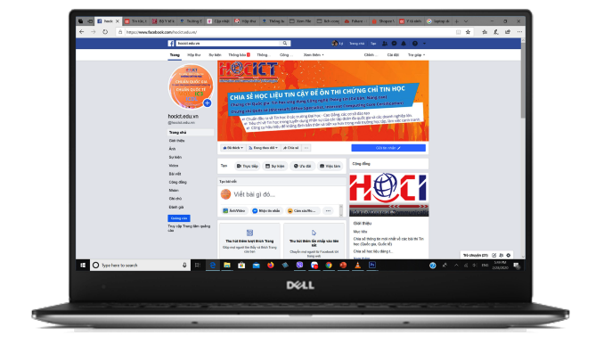Welcome to website https://blogdaytinhoc.com/. This website is used for sharing document, lecture, reference material without using storage device.

Moreover, students can check studying schedule, exam report, grade, etc. The website’ main contain covers lecture slides, curriculum, exercise is constructed by website owner and his colleagues.

The creators’ purpose is for studying, exchanging and sharing knowledge with positive construction not for profit.

# OVERVIEW

With the vision of sharing our knowledge of Information Technology in general and Informatic in specific, we create website Information Communications and Technologies to collect and rearrange educational materials and our own sources.

The website contains many literatures in different categories which have smaller groups so it is more convenience for readers. Besides, there are sections for top read articles, new articles, etc.

# LIST OF TOPICS

*The following table shows the inspection results – update Oct 2023:*

|  |  |  |  |  |
| --- | --- | --- | --- | --- |
| No. | **Categories** | **Quantity** | **Viewed** | **Responses** |
|  | Basic Informatics | 17 | 129 | 92 |
|  | Fundamental Computer | 28 | 291 | 197 |
|  | Graphic Computer | 20 | 292 | 201 |
|  | Multimedia | 32 | 392 | 231 |
|  | Web Technologies | 34 | 128 | 92 |
|  | Application Programming | 32 | 232 | 192 |
|  | Networking | 29 | 262 | 232 |
|  | Windows Mastery | 28 | 382 | 23 |
|  | Smart Phone | 19 | 408 | 231 |
|  | MOS – IC3 | 15 | 123 | 111 |

# MOS INTRODUCE

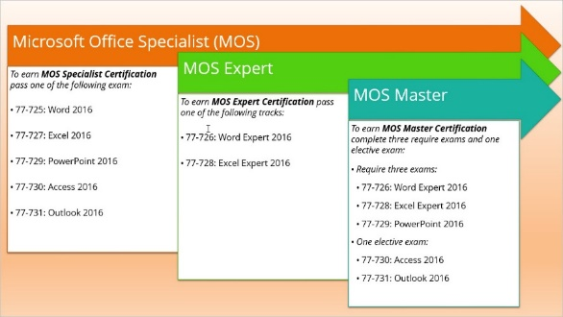MOS is an acronym for Microsoft Office Specialist which is the most widely used office computing skills test in the world with over 1 million tests taken annually.

The MOS test was created by Microsoft and performed by Certiport (USA). The exam is conducted online, with more than 25 languages ​​built, including Vietnamese.

**MOS is the only justification that validates your skills in using Microsoft Office and is directly certified by the CEO of the Microsoft Corporation**

## MOS Level

## MOS Version

MOS 2013 (Office 2013)

MOS 2016 (Office 2016)

MOS 2019 (Office 2019)

For more information, please visit fan page: https://blogdaytinhoc.com/.

|  |  |
| --- | --- |
|  |  |
|  |  |